1. Draw a state diagram for nondeterministic finite automata that accepts the following languages

There can be multiple answers, below is one example answer.

${(\left(ab\right)}^{*}{\left(ba\right)}^{*})∪{aa}^{*}$

${\left(ba∪b\right)}^{*}∪{\left(bb∪a\right)}^{*}$

1. Give the regular expression for the language accepted by the following finite automaton:

There can be multiple answers, below is one example answer.

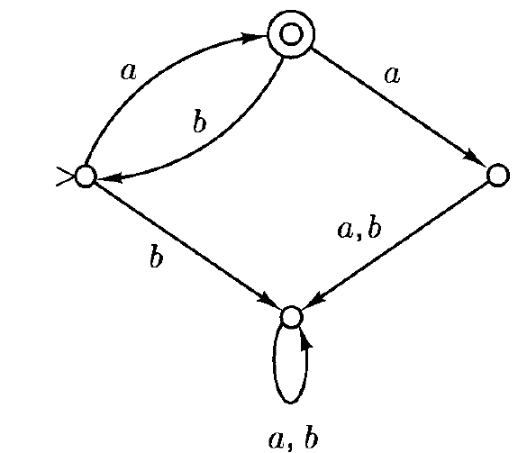

1. Write the regular expression for the following sets
   1. All strings over $\{a,b\}$ that are odd in length
   2. All strings over $\left\{a,b\right\}$ that end with $bb$